**WNR Design Strategy**

**Problem Description**

WNR seeks to produce a new ECoG (a.k.a. Intracranial EEG) electrode that incorporates wireless connectivity between each individual electrode and a central terminal. Each electrode will be attached to a low-power wireless control unit that will read and transmit neural data in real-time to a receiver. An array of up to 16 wireless electrodes should be able to transmit simultaneously to a single receiver. From the receiver, medical professionals can access and analyze the captured data to treat the patient.

**Problem Decomposition**

The overall system takes the following inputs and generates the following outputs:

1. Inputs: electrical pulses generated by the brain
2. Outputs: remotely received electrical signals in the brain

The main difference between our product and existing designs is that we will transmit the data to the receiver wirelessly from each individual probe, while most products on the market either directly connect their recording instruments to the receiver using wires or have a wireless module that is connected to a group of probes.

In order to achieve our final product, we have decomposed our design to the 4 parts, as illustrated in the diagram below.

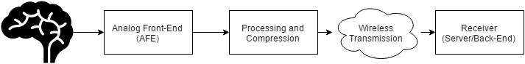

**Figure 1.** System block diagram of the wireless neural recorder.

The electrical signals from the brain will be sampled and digitized by the analog front-end. The analog front-end must ensure that the signal is recorded and digitized with a high signal-to-noise (SNR) and that the signal is amplified so that the signal amplitude is within the range of acceptable values of current analog-to-digital converter (ADC) technology. The output of the analog front-end is the digitized signal of the electric activity occurring at the site of contact between the electrode and the brain.

Once the signal is digitized, a microcontroller will process the digital signal for wireless transmission. Our application aims to be low-power. Since wireless transmission will consume the most power out of all the components of our system, we will have to reduce the amount of power consumed by wireless transmission. If we transmit raw data from all electrodes in the system simultaneously to the receiver, we may not have enough bandwidth using a low-power scheme to transmit the data in real-time from all electrodes. As such, we will have to apply compression or data decimation methods to reduce the amount of data we need to transmit to avoid overflowing the wireless transmission channel. This portion is addressed in the preprocessing and compression portion of the system.

After preprocessing, the data will be wirelessly transmitted to the receiver. Since wireless communication are more prone to noise than wired connections, rather complicated protocols are required to modify the packages to be sent. Fortunately, robust protocols like TCP already exist and can potentially be incorporated into our product.

Finally, the signals transmitted wirelessly will reach a receiver which could be a phone application that stores the data for users to view and analyze. Data could potentially be recorded and transmitted in real-time in order for our neural recorder to function as an effective real-time brain activity monitoring system. The back-end component of the system is extremely flexible. It can be a phone application, a personal computer, a server, etc. Since any of these options would satisfy the requirements of the system, the following sections do not detail the platform that will be used in the back-end system design. Instead since the front-end portion of the system have much more stringent requirements, the following sections will describe the decisions made about these subsystems in detail.

**Design Requirements**

The following design specifications were given to us by Dr. Nitin Tandon from UTHealth.

1. Dimensions:
   1. The entire device should fit in a cap of size 8 x 8 x 10 mm (ideally 5 x 5 x 10 mm).
2. Power:
   1. The device should operate continuously for at least 24 hours without changing the battery.
3. Electrode Specifications:
   1. An array of 16 electrodes
   2. Each electrode has 16 channels
4. Data Requirements:
   1. 1 kHz sampling rate for each channel on each electrode
   2. At least 8-bit ADC precision
   3. 1000 x 16 x 16 x 8 = 2 Mb/s raw data
5. Safety:
   1. Local temperature change around electrode should not exceed 2oC
   2. No backward current flow into patient’s brain

**Concept Generation**

1. Analog Front-End:

Given the low amplitudes of input signals, low-noise become a very important design requirement. At the same time, power consumption also needs to be considered as the system would need to fit in a very small form factor, hence limiting the size of the battery and the total power supply.

With these two design requirements in mind, we engaged in market research for commercially available AFE chips and found several options:

1. Intan Technologies – RHD2000 series

|  |  |
| --- | --- |
| **Component** | **Features** |
| ADC | * 16-bit * 32 channels * Max 30,000 Samples/Second |
| Amplifier | * Cutoff frequency adjustable:   + Upper: 100 Hz – 20 kHz   + Lower: 0.1Hz – 500 Hz * Input Referred Noise:   + 2.4 uVrms |
| Connection | * 16-bit SPI with either of the two signaling methods   + Standard – referenced to GND, more prone to noise   + LVDS – referenced to a negative pin, more resistant to noise |
| Additional Capabilities | * *In situ* electrode impedance measurement * Temperature sensor |
| Power Consumption | * Estimated (in **Appendix A**) to be 2.99 mW and 21.74 mAh for 24 hour continuous operation |
| Safety | * Built-in protective circuitry that prevents backward current flow into electrode * Built-in temperature sensor to monitor local temperature to avoid overheating |

**Table 1.** Features of Intan Technologies RHD2000 series

The Intan RHD2000 series, at a first glance, seems to provide everything that the project requires for the analog front-end. There are more than enough channels on the chip to read in 16 channels from the electrode, with very low lower cut off frequencies (as low as 0.1 Hz). Additionally, the amplifier has a very low input referred noise, which provides high signal-to-noise ratio amplification. The following table lists out the cost of the various products that is associated with the Intan RHD2000 series.

|  |  |  |
| --- | --- | --- |
| **Product** | **Specifications** | **Price (in $/unit)** |
| Amplifier Boards | RHD 2216 with 16 Bipolar inputs**++** | 725 |
| RHD 2132 with 32 Unipolar inputs | 895 |
| RHD 2164 with 64 Unipolar inputs | 1785 |
| Electrode Adaptor | Board | 255 |
| 36-Pin Wire | 190 |
| SPI Adaptor | Breakout for 12-pin SPI**++** | 98 |
| SPI cable | Standard 0.9m **++** | 215 |
| Ultra-Thin 0.9m | 415 |
| USB interface Board | Development Board for RHD2000 series | 2755 |

**Table 2.** Costs of Intan Technologies RHD2000 series and related Products.

( **++**: Minimum components required)

A complete evaluation system of Intan RHD2000 will cost from $3793 to $5488. With a minimum development cost of $1038 for only the amplifier board.

However, we can lower the cost by only purchasing the amplifier board with SPI cable and SPI adaptor board which will cost a total of $1038 - $2098 (depending on the choice of amplifier board).

1. Texas Instruments - ADS1299

|  |  |
| --- | --- |
| **Component** | **Features** |
| ADC | * 24-bit delta-sigma ADC * 8 channels * Max 16,000 Samples/Second |
| Amplifier | * Programmable Gain:   + 1,2,4,6,8,12,24 * Bandwidth scales with respect to gain:   + 622 kHz(1x gain) - 27 kHz (24x gain) * Input Referred Noise:   + 1.0 uVpp |
| Connection | * standard SPI |
| Additional Capabilities | * Temperature sensor |
| Power Consumption | * 5 mW/Channel |
| Safety | * Patient protection resistor |

**Table 3.** TI ADS1299 Features

|  |  |  |
| --- | --- | --- |
| **Product** | **Specifications** | **Price (in $/unit)** |
| ADS1299 | * Only come in TQFP packagings * Sell in quantities of thousands | 0.038 |
|
|

**Table 4.** TI ADS1299 Cost

1. Preprocessing and Compression:

From the design requirements provided, a transmission rate of 2 Mb/s would only be satisfied if a higher power higher bandwidth wireless communication protocol, such as Wi-Fi, is used. The theoretical channel capacity of a lower power protocol, like Bluetooth Low Energy (BLE), is 1Mb/s, so the raw data should be compressed by at least a factor of two for reliable transmission.

The compression algorithm that was considered is called Adaptive Huffman Coding. This algorithm dynamically adjusts the Huffman tree data structure as data is being transmitted. An example of the Huffman tree data structure and the corresponding coding scheme is shown below.

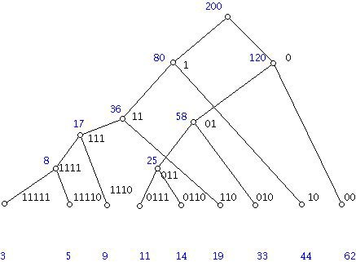

**Figure 2.** Example of Huffman tree with frequencies of codewords listed below[14]

The Huffman tree is a data structure that assigns long bit sequences with a short prefix representation, denoted by the path representing the bit sequence travelling down along the tree. Regular Huffman trees use fixed tree structures, where each long bit sequence is stored in a fixed location. Adaptive Huffman tree simply updates this tree structure by the frequency of occurrence of each bit sequence, by consecutively swapping nodes and leaves to achieve optimized performance. In figure 2, the frequency of each bit sequence is shown listed below the tree, and it follows that the most frequently occurring sequence is represented with the smallest number of bits. Huffman encoding is also a relatively common algorithm which makes implementation more convenient. The compression rate for Huffman encoding is at most 40%, which is slightly less than a reduction by a factor of two[14]. This method provides a starting point to run begin wireless transmission testing once the prototype has been built. We will keep exploring other compression algorithms, especially if Huffman encoding turns out to be insufficient.

1. Power Source:

Our power needs is one of the biggest challenges as our design requirements are quite aggressive. The device must meet or exceed the following expectations:

1. Last 24 hours while collecting data
2. Only change or charge device at most once per waking day
3. We calculated the capacity of our system had to provide at minimum 240 mAh
4. Be medically safe
5. Do not return DC current into needle probe into brain
6. Do not heat up above 2 degrees centigrade
7. Be within the total size constraints of maximum 8mm diameter by 10mm height

Powering such a device that is so small yet so power hungry proves to be a big challenge that required extensive energy research. The research ranged from unconventional medical device techniques such as wireless charging[5] to tried and true conventional methods such as batteries. Given that the brain is a very sensitive and important part of our lives and our device will be directly interfacing with it, we decided to go with the more conventional and safer option of powering the intracranial EEG data recorder with batteries. However, even using battery technology, there was still a large amount of work to be done in order to decide on a battery technology that could best fit our needs.

The first area of research would be the battery chemistry to use for our battery. Items that were under consideration were energy density, discharge rate, safety, weight and size, and lastly cost. There were dozens of battery chemistries, each with their pros and cons for specific applications in regards to performance and cost. In figure 3, the 6 most common battery make-ups are compared but only Lithium[7] based batteries could provide us the energy density for the size, weight, and capacity that we required. However even then, Lithium based batteries, while popular, could not be the only technology we look into as it still had several cons despite class leading energy density and low discharge rate. A flaw in Lithium based technologies is that it requires protection circuits to limits voltage and current and the lithium battery is safe if not provoked by extreme temperatures or physical damage. While these were somewhat minor cons that could be designed against to meet our second requirement of being safe, we researched into less conventional batteries such as silver-zinc and zinc-air[8].

Zinc-air, a less conventional battery chemistry but now highly common in hearing-aid devices, caught our attention and seemed to be a viable competitor to Lithium based batteries. Zinc-air batteries generate electrical power by an oxidation process of zinc and oxygen from the air and as such it has high specific energy, low discharge, and comes in a variety of sizes while also staying low-cost[9] and low weight due to the lack of need to package atmospheric air for its operation.

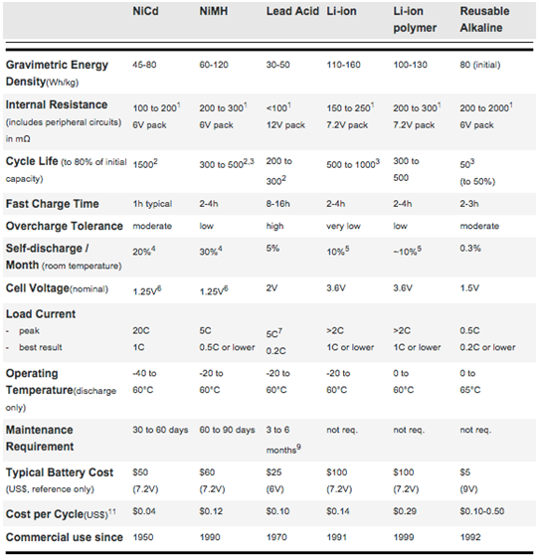

**Figure 3.** Comparison of 6 Common Battery Types[6]

1. Wireless Transmission:

Our data transmission needs continues to prove itself as our biggest challenge as we are sending large amounts of data continuously. Our device was given the following requirements as an optimal operating mode:

1. Support up to 16 intracranial probes
2. Each intracranial probe has 16 electrodes
3. Each electrode outputs 8 bits, sampled at 16 bits due to Nyquist Frequency
4. Data sampled at 1 ks/s
5. Send data over a range of at least 3 m

Given the worse case scenario, our device will use 16 x 16 x 16 x 1 bits = 4 Mb/s. This is a lot of data to be transmitted in parallel, continuously every second. However after consulting with our PhD mentors, professors, and TI engineers, we concluded that our device could possibly work well with sending less data with a few techniques such as decimation, compression, and buffering. Instead of sending the full 4 Mb, it would instead:

1. Each electrode outputs 8 bits, sampled at 16 bits but decimated back to 8 bits during transmission
2. Data sampled at 0.5 ks/s instead of 1 ks/s because most of the data is low frequency

This makes our worse case scenario a little bit better, as our device will use 16 x 16 x 8 x 0.5 = 1 Mb/s. This is a 4x reduction in necessary bandwidth, which is much more reasonable and achievable. This reduction in bandwidth requirements before compression allows us to consider multiple wireless technology options and different network topologies[15]. A table of a few notable comparisons between technologies is listed:

|  |  |  |  |  |  |  |  |  |
| --- | --- | --- | --- | --- | --- | --- | --- | --- |
|  | Bluetooth Low Energy  (LE) | Wi-Fi | Radio Frequency for Consumer Electronics  (RF4CE) | ANT+ | Nike+ | Infrared  Data Association  (IrDa) | ZigBee | Near Field  Commu-nication  (NFC) |
| Cost | Low | High | Medium | Medium | Medium | Low | Low | Medium |
| Power  Efficiency | 0.153 μW/bit | 0.00525 μW/bit | <185.9 μW/bit | 0.71 μW/bit | 2.48 μW/bit | 11.7 μW/bit | 185.9 μW/bit | >185.9 μW/bit |
| Operating  Range | 100m | 150m | 100m | 30 m | 10 m | 10 cm | 100m | 5 cm |
| Throughput | 1 Mbps | 54 Mbps | ~424 kbps | ~20 kbps | ~20 kbps | ~1 Gbps | ~100 kbps | ~424 kbps |
| Latency | 2.5ms | 1.5ms | ~20ms | ~0 | ~1s | ~25ms | ~20ms | ~1s |
| Peak Current  Draw | ~ 12.5 mA | ~ 116 mA | ~ 40 mA | ~ 17 mA | ~ 12.3 mA | ~ 10.2 mA | ~45 mA | ~ 50 mA |

**Table 5.** Comparison of wireless transmission protocols

We also looked into network topologies and our research included the 5 main network topologies exist when discussing personal low-power radio networks:

1. Broadcast: A message is sent from a device in the hope that a receiver within range receives it. The broadcaster doesn't receive signals.
2. Mesh: A message can be relayed from one point in a network to any other by hopping through multiple nodes.
3. Star: A central device can communicate with a number of connected devices — Bluetooth is a common example.
4. Scanning: A scanning device is constantly in receive mode, waiting to pick up a signal from anything transmitting within range.
5. Point-to-Point: In this mode, a one-to-one connection exists, where only two devices are connected, similar to a basic phone call.

The wireless technologies we looked at can support the following network topologies as seen in figure 4.

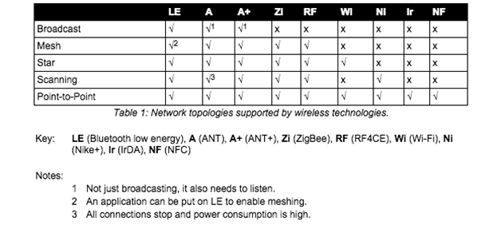

**Figure 4.** Wireless Technology Network Topology

There was another technology that we found called Ultra Wideband (UWB)[16], as seen in figure 5, that could have fulfilled all our needs and given us the 4 Mb/s bandwidth that would have given us the most optimal performance but unfortunately the standard was abandoned due to fighting between competing factions. Unfortunately that puts UWB out of the running even though it had to potential to be a great wireless technology for our needs. Amongst the existing technologies, given that only Bluetooth Low Energy and Wi-Fi meet our throughput and operating range needs, we narrowed it down to those two technologies to weigh the pros and cons of the two. However, given that Wi-Fi has a high power draw, compute resources, and slightly higher cost, we decided to choose Bluetooth Low Energy as the wireless technology that we will focus on in creating our prototype due to the fact that is has great range, low power draw, and decent throughput at 1 Mb/s.

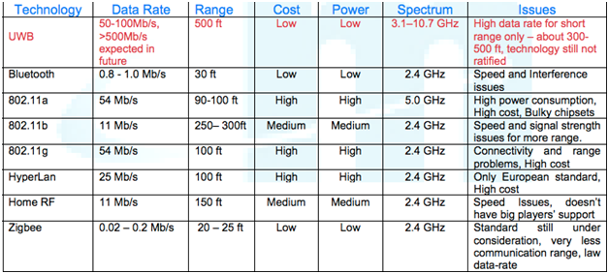

**Figure 5.** UWB vs. BLE vs. Wi-Fi

The Bluetooth radio interface has been designed to enable communications to be made reliably over short distances. The radio interface is relatively straightforward, although it has many attractive features. The Bluetooth radio interface supports a large number of channels and different power levels, as well as using reliable forms of modulation. Running in the 2.4 GHz ISM band, Bluetooth employs frequency hopping techniques with the carrier modulated using Gaussian Frequency Shift Keying (GFSK). With many other users on the ISM band from microwave ovens to Wi-Fi, the hopping carrier enables interference to be avoided by Bluetooth devices. A Bluetooth transmission only remains on a given frequency for a short time, and if any interference is present the data will be re-sent later when the signal has changed to a different channel, which is likely to be clear of other interfering signals. The standard uses a hopping rate of 1600 hops per second, and the system hops over all the available frequencies using a predetermined pseudo-random hop sequence based upon the Bluetooth address of the master node in the network.

Bluetooth Low Energy shares some similarities with Classic Bluetooth. Both use the 2.4 GHz spectrum. Basic Rate (BR) and BLE both use GFSK modulation at 1Mb/s, but their modulation index is different. Enhanced Data Rate (EDR) uses a completely different modulation than GFSK. Classic Bluetooth has 79 channels compared to LE’s 40 channels. The channels are also spaced differently. Both of these differences make LE and Classic different and incompatible, so they can’t communicate to each other[17]. We can see the difference between Bluetooth Low Energy and Classic in figure 6, with Bluetooth Low Energy being able to theoretically support our 1 Mb/s bandwidth requirements.

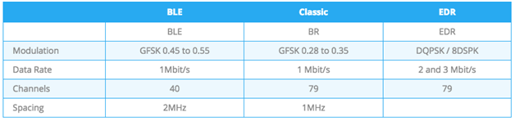

**Figure 6.** Comparison Between BLE and Classic

Bluetooth Smart has two ways of communicating. The first one is using advertisements, where a BLE peripheral device broadcasts packets to every device around it. The receiving device can then act on this information or connect to receive more information. The second way to communicate is to receive packets using a connection, where both the peripheral and central send packets. BLE Advertising is one of the most important aspects of Bluetooth Low Energy. This is seen, as a connection between two devices without using advertisements is impossible. Defining the data and format of advertisement packets is usually the first thing you work on when developing a BLE device. Also, a large number of BLE products sleep most of the time, waking up only to advertise and connect when needed. This means advertisements have a big impact on power consumption.

The 2.4GHz spectrum for Bluetooth extends from 2402 MHz to 2480 MHz, as seen in figure 7. LE uses 40 1 MHz wide channels, numbered 0 to 39. Each is separated by 2MHz. Channels 37, 38, and 39 are used only for sending advertisement packets. The rest are used for data exchange during a connection. During BLE advertisement, a BLE Peripheral device transmits packets on the 3 advertising channels one after the other. A Central device scanning for devices or beacons will listen to those channels for the advertising packets, which helps it discover devices nearby.

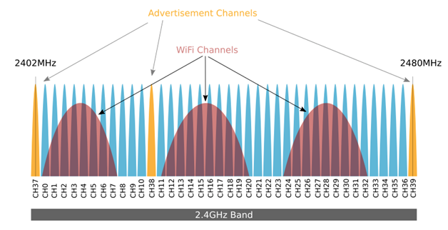

**Figure 7.** Bluetooth Channels

We researched and found that for Bluetooth Low Energy, the current standard is BLE 4.2, which is more power efficient and secure but Bluetooth v4.2 hasn’t made it yet to the market completely because it requires updated hardware and because it requires support on both sides of the link for transmitting and receiving. We also notice that most of the devices available are Single Mode only, and that most of those run v4.1 of the Bluetooth Specification, which is still new but well documented and still decently low power. We also noticed that dual Mode devices are not as popular because of cost and the complexity of supporting Bluetooth Classic and BLE on the same chip.

Looking into the current vendors and existing chipsets, there are a variety of options. However given that the ideal size constraint of the system (5 x 5 x 10 mm) is very small, our options for components are limited. The first option is the TI CC2650 chip. Its features and specifications are given below.

1. Texas Instruments - CC2650

|  |  |
| --- | --- |
| **Component** | **Features** |
| ADC | * 12-bit ADC * 8 channels * Max 200,000 Samples/Second |
| Transceiver | * 2.4 GHz RF Transceiver * Bluetooth Low Energy (BLE) 4.1 * Programmable output power up to +5 dBm |
| Microcontroller | * ARM Cortex M3 * Up to 48 MHz clock speed * 128 KB of In-System Programmable Flash * 8 KB SRAM for cache |
| Peripherals | * I2C * SPI * UART |
| Size | * 4 x 4 mm |
| Cost | * $5.95/unit |

**Table 6.** TI CC2650 features

Of the features listed in the table, the main components of interest are the transceiver, for transmitting data, and the microcontroller. The transceiver is directly used for data transmission. The microcontroller is useful for several applications other than wireless transmission and reading data from the analog front-end. It can also be used for processing and compressing data read from the analog front-end. Since the analog front-end will be a separate part of the system, the ADC component of the CC2650 does not need to be utilized. The following table lists out some of the specifications of the CC2650.

|  |  |
| --- | --- |
| **Specification** | **Value** |
| Wide Supply Voltage Range | * Normal Operation: 1.8 to 3.8 V * External Regulator Mode: 1.7 to 1.95 V |
|
|
| Active-Mode Transmission | * 0 dBm: 6.1 mA * +5 dBm: 9.1 mA |
| Active-Mode Receiver | * 5.9 mA |

**Table 7.** TI CC2650 specifications

The table shows that the same power supply of 3.3V used for the Intan RHD2000 series, described in the previous section, can also be used for the CC2650 chip. The main specification of interest is the Active-Mode transmission, since this specifies the amount of current the device draws as it undergoes wireless transmission. Calculations for the current draw and power consumption of the TI CC2650 chip is found in **Appendix B**.

Another option, suggested by Texas Instruments engineers, is to use the TI CC110L Value Line Transceiver to create a star topology of point-to-point connections from the receiver to all of the electrodes. Some of its features are enumerated below.

|  |  |
| --- | --- |
| **Component** | **Features** |
| RF | * Output power up to 12 dBm * Up to 600 kb/s data rate * Three sub GHz frequency bands supported * Signal modulation supported |
| Low-Power | * 200 nA sleep mode current consumption * 240 micro-second wakeup time * 64-byte RX and TX FIFO |
| Size | * 4 x 4 mm |

**Table 8.** TI C110L features

The feature listed above that is most important to the project is the 600 kb/s data rate. This data rate is lower than the effective BLE data rate, which is around 750 kb/s. This means that using the C110L would decrease the system’s channel capacity. Of course, the most important specification that our system depends upon is the transmission power consumption. The following table provides the current consumption required for transmission at specific frequencies.

|  |  |
| --- | --- |
| **Transmission Frequency** | **Minimum Current Draw** |
| 315 MHz | * 12.3 mA |
| 433 MHz | * 13.1 mA |
| 868/915 MHz | * 14.7 mA |

**Table 9.** TI C110L transmission current draw

The current draw for transmission with the TI C110L is at least twice as much as transmission with the TI CC2650, making the TI C110L a less power efficient product in our project than the TI CC2650. Power consumption is calculated and analyzed in **Appendix B**.

**Concept Screening**

1. Analog Front-End (AFE):

After considering varying design criteria for AFE, Pugh Decision-Matrix was used to compare the Intan RHD2000 option and the TI ADS1299 option. Pugh Decision-Matrix is shown on the next page.

|  |  |  |  |  |
| --- | --- | --- | --- | --- |
| Criteria | Baseline | Weight | Intan RHD 2000 | TI ADS1299 |
| High precision ADC | 8-bits | 3 | + | + |
| Low Noise Amplifier | 3 uVrms | 4 | + | + |
| Safety | Protected circuitry and no backward current | 6 | + | - |
| Power Consumption* | << 300 mAh | 2 | S | S |
| Small Form Factor | < 8 x 8 mm | 5 | + | - |
| Cost | $100 | 1 | S | + |
|  |  | Total | 18 | -3 |

* Baseline determined based on battery constraints

**Table 10.** Pugh Decision-Matrix for AFE

(**+** : beyond satisfactory, **-** : not satisfactory, **S**: Satisfactory)

The Pugh Decision-Matrix clearly shows, Intan RHD2000 is a better option than the TI ADS1299. Hence, going forward the Intan RHD2000 chip will be integrated into the system.

1. Power Supply:

Given the choice between Zinc-Air and Lithium, we decided that while Lithium has a slightly higher energy density, its power stability cons and bigger standard size factors[10] were a limiting factor for us. We decided that Zinc-air’s small form factors would be our best viable option. The zinc-air batteries that we found for medical hearing aids came in 4 standard sizes, shown in figure 8, with varying diameter, height, and capacity. The only issue that we found was that the zinc-air batteries only provides 1.45V per cell but enough capacity at 300mAh at the p13 size. We believe that if we stack 2 p13 cells in series, we can get away with powering our devices at 2.9V, which is close enough to 3V, and that will continue to give us the 300mAh of the battery. This should be sufficient for our needs if our calculations are correct that our device should consume about 240mAh, which will give us 60mAh of buffer. This means that our capacity constraints are met but our size constraint would be slightly taller than what is optimal, as two batteries stacks would be 10.8mm, not including the rest of the components. However, we can ask for a height exception, as we would be creating prototypes and not creating custom batteries, which if we do for the production run, the battery size can fit within size constraints.

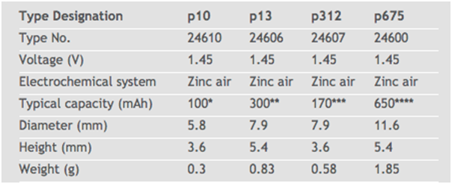

**Figure 8.** Zinc Air Battery Sizes

1. Wireless Communications:

The two components considered for the microcontroller and wireless transmission are the TI CC2650 and the TI C110L Transceiver, which were outlined in the Concept Generation section. Again, a Pugh Decision-Matrix will be used to compare both options against the specifications detailed in the Design Requirements Section.

|  |  |  |  |  |
| --- | --- | --- | --- | --- |
| Criteria | Baseline | Weight | TI CC2650 | TI C110L Transceiver |
| Power Consumption* | < 300 mAh | 4 | + | - |
| Transmission Speed** | 1 Mb/s | 6 | S | - |
| Small Form Factor | < 8 x 8 mm | 2 | + | + |
| Cost | $100 | 1 | + | + |
|  |  | Total | 7 | -7 |

* Baseline determined based on battery constraints

** Assuming that compression reduces data rate by a factor of 2

**Table 10.** Pugh Decision-Matrix for wireless transmission chip

(**+** : beyond satisfactory, **-** : not satisfactory, **S**: Satisfactory)

As shown in the Pugh-Decision Matrix, the CC2650 is superior to the TI C110L transceiver for the wireless neural recorder, which requires large amounts of bandwidth and be low-power. The C110L does not meet the system’s requirements in terms of these specifications. **Appendix B** outlines the power consumption of both systems. The CC110L requires slightly less than 300 mAh, which for this analysis is rounded to 300 mAh (this is a reasonable approximation considering this 300 mAh figure was determined using the settings that consumed the least amount of power on the chip), so it does not meet the baseline power constraints.

**Design Decisions Summary**

1. AFE:
   1. Intan Technologies RHD2000 amplifier board + SPI cable + SPI adaptor
2. Processing and Compression
   1. Huffman Encoding
3. Wireless transmission:
   1. Bluetooth Low Energy (BLE)
   2. TI CC2650

**Appendix A. Power Estimation for Intan RHD2000**

Total Power consumption of Intan RHD2000 is estimated for ECoG applications as per our project with the following specifications:

1. High cutoff frequency of 1kHz
2. Sample rate = 16 channels * 1 kS/s/channel = 16 kS/s
3. I/O, impedance measurement and temperature sensor turned off
4. Operating for 24 hours
5. Supply voltage of 3.3V

Power consumption for RHD2000 is listed as below:

1. Amplifier:
   1. Baseline = 200 uA
   2. Per kHz of upper cutoff frequency per ADC channel = 7.6 uA
2. ADC:
   1. Baseline = 510 uA
   2. Per kSamples per second per channel = 2.14uA
3. Supply Voltage, Auxiliary Inputs
   1. 40 uA

The total power consumption is then estimated as follows:

1. Amplifier current: 200 uA + 16*7.6uA/kHz*1 = 321.6 uA
2. ADC current: 510 uA + 2.14 uA/(kSample/s)*16 = 544.24 uA
3. Supply Voltage, Auxiliary Inputs: 4*10uA = 40 uA

Hence the total power consumption is 3.3V *(321.6+544.24+40)*(10^-6) = 2.99 mW. For continuous operation of 24 hours, it corresponds to 21.74 mAh.

**Appendix B. Power Estimation for TI CC2650 and TI CC110L**

First, the power consumption derivations of the TI CC2650 are shown below[11].

1. Transmission at +0 dBm:
   1. Consumes 6.1 mA
   2. Power consumption with 3.3 V supply: 3.3 V * 6.1 mA = 20.13 mW
   3. To transmit continuously for 24 hours = 6.1 mA * 24 hours = 146.4 mAh
2. Transmission at +5 dBm:
   1. Consumes 9.1 mA
   2. Power consumption with 3.3V supply: 3.3 V * 9.1 mA = 30.03 mW
   3. To transmit continuously for 24 hours = 9.1 mA * 24 hours = 218.4 mAh

It is highly unlikely that a transmission power of greater than +0 dBm, so using an estimation of approximately 150 mAh (battery energy density required to transmit at +0 dBm for 24 hours) will suffice for analyzing the power feasibility of the system.

Next, the power consumption derivations of the TI CC110L are shown below[13].

1. Transmission at 315 MHz:
   1. Consumes 12.3 mAh
   2. Power consumption with 3.3 V supply: 3.3 V * 12.3 mA = 40.59 mW
   3. To transmit continuously for 24 hours = 12.3 mA * 24 hours = 295.2 mAh

Transmission at 315 MHz consumes the least amount of power of all the transmission frequencies, and even then this transmission mode requires much more power than that of the CC2650. Additionally in order to use the C110L, the device must be connected to an external controller, like the TI MSP432. If the microcontroller is assumed to be in low-power mode for the entirety of the transmission period, then its effective current consumption is 0[12]. From the pure power consumption perspective, the CC2650 is the better choice for the project.

**References**

[1] "Intan Technologies, LLC: Low-noise Amplifier Microchips for Electrophysiology, EKG, EMG, EEG, ECoG, and Neural Recording Headstages and Bio Instrumentation." *Pricing*. Web. 22 Oct. 2015.

[2] "Digital Electrophysiology Interface Chips." INTAN TECHNOLOGIES, LLC, 11 Dec. 2012. Web. 22 Oct. 2015.

[3] "Low-Noise, 8-Channel, 24-Bit Analog Front-End for Biopotential Measurements." Texas Instruments, 1 July 2012. Web. 22 Oct. 2015.

[4] Giuliano Antoniol and Paolo Tonella, “EEG Data Compression Techniques”, *IEEE TRANSACTIONS ON BIOMEDICAL ENGINEERING*, VOL.44, NO.2, Feb 1997.

[5] Tseng, R., B. Von Novak, S. Shevde, and K. A. Grajski. "Introduction to the Alliance for Wireless Power (A4WP) Loosely- Coupled WPT Specification 1.0." Introduction to the Alliance for Wireless Power (A4WP) Loosely- Coupled WPT Specification 1.0 (2013): n. pag. IEEE, 15 May 2013. Web. 21 Oct. 2015.

[6] "What's the Best Battery?" Advantages and Limitations of the Different Types of Batteries. Battery University, 01 Nov. 2010. Web. 21 Oct. 2015.

[7] "Battery Chemistry Comparison Chart." Battery Chemistry Comparison Chart. ICCNexergy, n.d. Web. 21 Oct. 2015.

[8] "Weird and Wonderful Batteries." Weird and Wonderful Batteries. Battery University, 17 Aug. 2011. Web. 21 Oct. 2015.

[9] Dondelinger, Robert M. "Batteries: From Alkaline to Zinc-Air." (2004): n. pag. FDA, Mar. 2004. Web. 21 Oct. 2015.

[10] "Battery Cell Types." Most Common Primary Battery Sizes Available. Epec, n.d. Web. 21 Oct. 2015.

[11] "CC2650 SimpleLink™ Multistandard Wireless MCU." Texas Instruments, 1 Feb. 2015. Web. 22 Oct. 2015.

[12] "MSP432P401x Mixed-Signal Microcontrollers." Texas Instruments, 1 Mar. 2015. Web. 22 Oct. 2015.

[13] "CC110L Value Line Transceiver." 1 May 2011. Web. 22 Oct. 2015.

[14] "Huffman Codes." *American Mathematical Society*. Web. 22 Oct. 2015.

[15] "Comparing Low-Power Wireless Technologies." *DigiKey Electronics*. DigiKey Electronics. Web. 23 Oct. 2015.

[16] "A Technology Comparison: Adopting Ultra-Wideband for Memsen’s File Sharing and Wireless Marketing Platform." Memsen Corporation. Web. 23 Oct. 2015.

[17] "A BLE Advertising Primer." *Argenox Technologies*. Web. 23 Oct. 2015.